

INTEGRATION POINT LEVEL CALCULATION FOR SMALL AND LARGE DEFORMATION
Course Title – Theory of Elasticity
Course Code – ME730

Submitted To:
Mayank Chouksey
Assistant Professor
Department of Mechanical Engineering IIT Indore
Submitted By-
Krishnagopal Gupta
(2502103022)

Utkarsh Dubey
(2502103026)
Problem Statement
- The aim of this project is to build a MATLAB program that updates stresses at the integration-point level for various motions, using both small-strain and finite-strain descriptions. The deformation is applied in incremental form, and at every step the only input to the code is the increment of the deformation gradient $ΔF$. Starting from the undeformed configuration where $F_{0}=I$, the total deformation gradient is updated sequentially as

Fn+1​=ΔF*Fn​.

Using each updated deformation gradient, the code must compute the velocity gradient,
$$l_{n+1}≈ΔF F_{n+1}^{-1},$$
and from it obtain the rate of deformation tensor,
$$d=\frac{1}{2}(l+l^{T}).$$

- These quantities are then used to evaluate the appropriate strain measures under both modelling frameworks. The stress update follows a rate-form constitutive equation, for example the Jaumann stress rate:

$$σ∇=C:d,$$
where $C$represents the elastic stiffness tensor. In the small-strain case, changes in geometry are neglected, allowing the stress rate to be approximated using the linear strain rate $\dot{ε}$, whereas in the finite-strain setting rotational effects and geometric nonlinearity must be included through the objective stress rate.
Because the loading is homogeneous, the code must also include an equilibrium consistency check and clearly state which configuration is used for this verification. After computing the stress response for an entire deformation history, the program should generate a single plot comparing the equivalent stress–equivalent strain curves obtained from the small-deformation and large-deformation formulations.

Constitutive Relation

In this project Quartz (Anisotropic material) has been taken which has been six independent elastic constants.
- It is a special class of anisotropic material, with trigonal symmetry.

$$σ_{ij}=C_{ijkl}ε_{kl}$$

$$\left\{\begin{aligned}σ_{1} \\ σ_{2} \\ σ_{3} \\ σ_{4} \\ σ_{5} \\ σ_{6}\end{aligned}\right\}=\left[ \begin{matrix}C_{11} & C_{12} & C_{13} & C_{14} & 0 & 0 \\ C_{12} & C_{11} & C_{13} & -C_{14} & 0 & 0 \\ C_{13} & C_{13} & C_{33} & 0 & 0 & 0 \\ C_{14} & -C_{14} & 0 & C_{44} & 0 & 0 \\ 0 & 0 & 0 & 0 & C_{44} & C_{14} \\ 0 & 0 & 0 & 0 & C_{14} & C_{66}\end{matrix}\right]\left\{\begin{aligned}ϵ_{1} \\ ε_{2} \\ ε_{3} \\ {2ε}_{4} \\ {2ε}_{5} \\ {2ε}_{6}\end{aligned}\right\}$$
$$c_{66}=\frac{1}{2}*(c_{11}-c_{12})$$

Small vs Large Deformation
- Small Deformation
Displacements and rotations are small, and the overall geometry of the body remains almost the same as the original one.
- The slopes (gradients of displacement) are so small that their squared terms can be ignored.
- Rotations are so small that they do not affect the stress calculation.
$$∈=\frac{1}{2}(∇∪+ {∇∪}^{T })$$
- After calculating the strain($∈$) we have used Cauchy stress

- Large Deformation
This is used when the body undergoes noticeable stretching, twisting, or rotation.
Here, the shape of the body changes significantly, and ignoring nonlinear terms would give completely wrong results.
- Rotations are no longer “small” — they must be treated properly.
- The deformation can distort the geometry to the point where the original and current shapes look quite different.
- The kinematic relations have to include nonlinear terms.
E =$\frac{1}{2}(F^{T}F-I)$
- After calculating this strain (E) we used 2nd Piola-Kirchhoff stress tensor to calculate the objective stress due to large deformation.
PLOT AND KEY INTERPRETATION

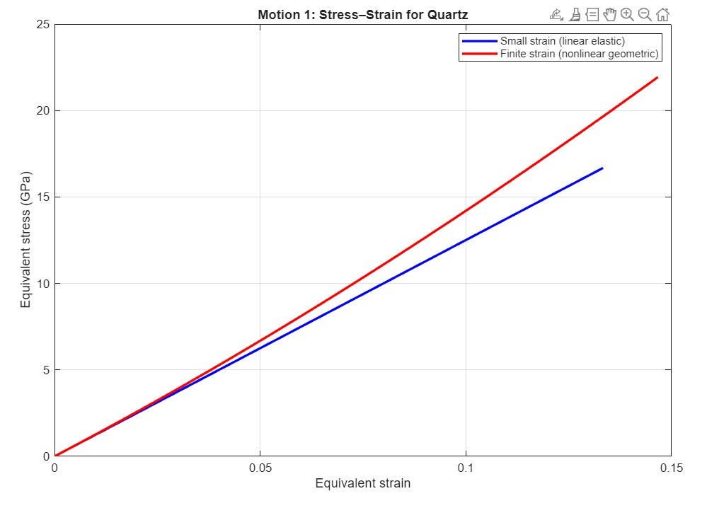
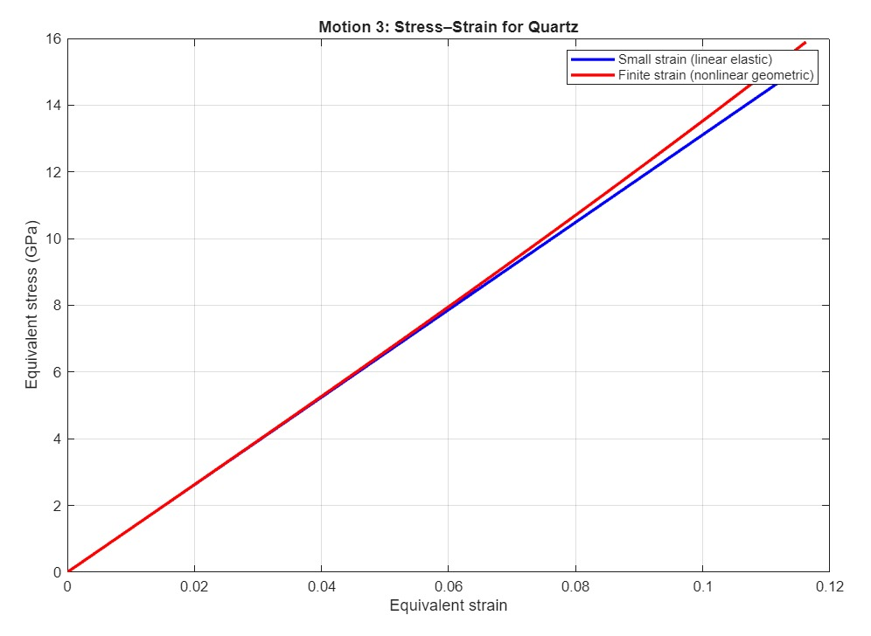
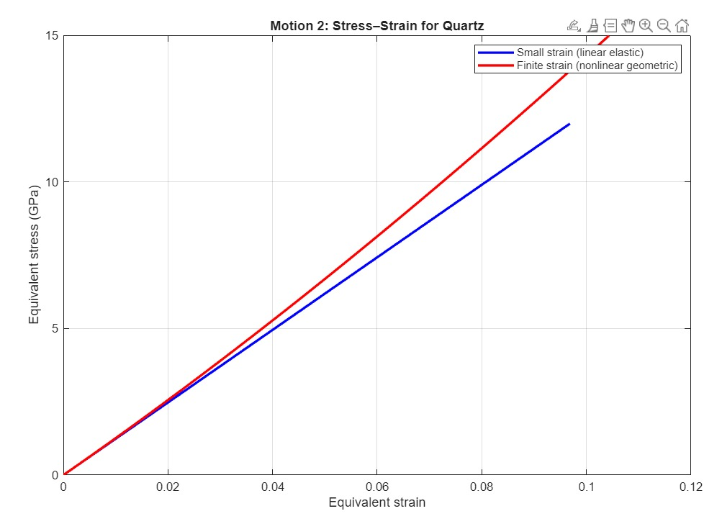
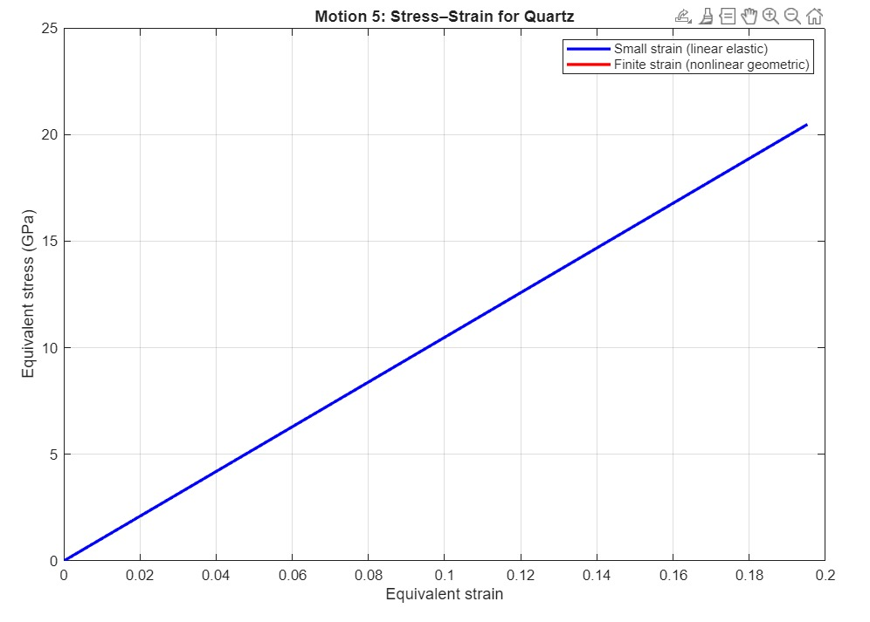
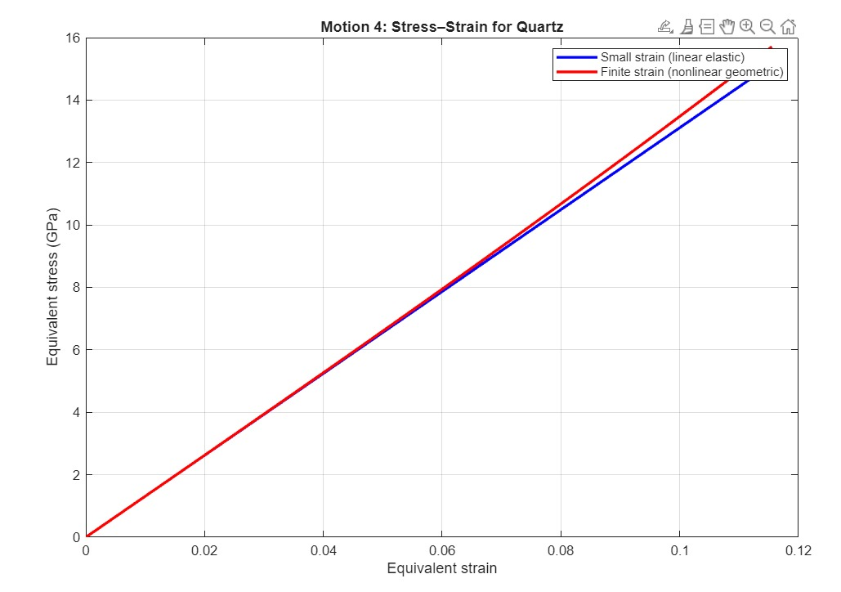

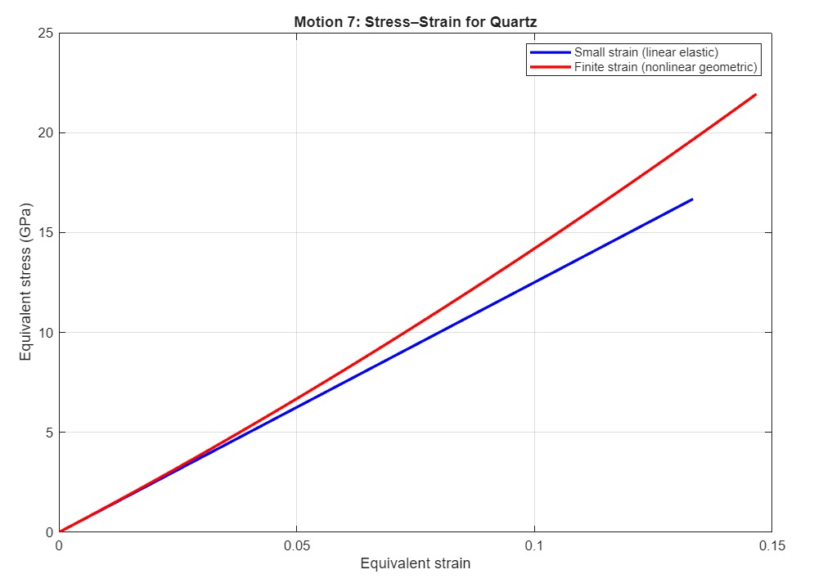
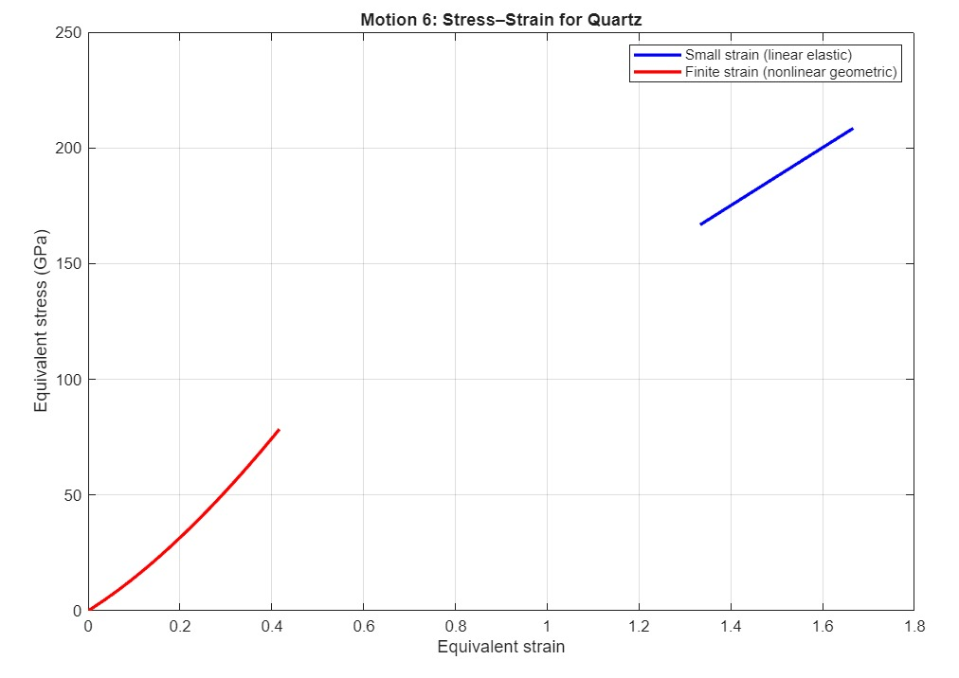
- Motion 1 — Uniaxial Extension
Stretch only in one direction that is classic tensile loading.
Stress–strain response mainly governed by the stiffness along that axis.
Finite-strain curve shows mild geometric nonlinearity; small-strain remains linear.
- Motion 2 — Biaxial Extension
Deformation applied in two directions simultaneously.
Produces higher stresses than uniaxial due to multi-axial coupling in anisotropic quartz.
Finite-strain response more nonlinear because multiple strain components grow together.
- Motion 3 — Simple Shear
Only shear deformation is applied (no extension).
Finite-strain curve slightly nonlinear due to quadratic shear strain term.
- Motion 4 — Double Shear
Two shear components activated simultaneously.
Leads to higher stress than simple shear and stronger anisotropic coupling.
Finite-strain curve shows noticeable nonlinearity due to multi-directional shear effects.

- Motion 5 — Rigid Body Rotation
Pure rotation with no actual material strain.
Finite-strain formulation correctly gives zero stress and strain because the body is in pure rotation so the deformation will not account for any strain but only change is orientation of the body.

- Motion 6 — Inversion / Compression
Material compressed and mirrored in one axis.
Stress grows rapidly since magnitude of stretch increases even with sign flip.
Strong geometric nonlinearity due to negative determinant and anisotropic stiffness.

- Motion 7 — Non-Homogeneous Extension
Deformation varies with position so the strain gradient will be across the material.
Produces the most nonlinear behaviour due to spatially varying stretch.
Stress affected strongly by anisotropic moduli and position-dependent strain.
Method Used:
- Material model and stiffness
The material is modelled as a linear anisotropic elastic solid with stiffness components chosen to represent quartz-like behaviour. The stiffness tensor in Voigt notation, $C$, is assembled from the independent constants $c_{11},c_{33},c_{44},c_{12},c_{13},c_{14}$and the derived shear constant $c_{66}=(c_{11}-c_{12})/2$. Units are GPa and the Voigt convention used treats engineering shear strains as $2ε_{ij}$in the shear positions of the strain vector.

- Different Motions
Seven distinct homogeneous (except one spatially varying) deformation mappings were considered. Each mapping defines a deformation gradient $F$parameterized by a pseudo-time $t∈[0,1]$(a nondimensional loading parameter):
- Uniaxial extension: $F=diag(α,1,1)$, $α=1+0.2t$.
- Biaxial extension: $F=diag(α,β,1)$, $α=1+0.t, β=1+0.15t$.
- Simple shear: $F=\begin{matrix}1 & γ & 0 \\ 0 & 1 & 0 \\ 0 & 0 & 1\end{matrix}$, $γ=0.2t$.
- Double shear: $F=\begin{matrix}1 & γ & 0 \\ γ & 1 & 0 \\ 0 & 0 & 1\end{matrix}$, $γ=0.1t$.
- Rigid body rotation: rotation in the 1–2 plane by $θ=(π/4)t$; $F$is the corresponding rotation matrix.
- Inversion / compression: $F=diag(-α,1,1)$, $α=1+0.5t$(mathematical flip along axis 1).
- Non-homogeneous extension: $F_{11}=1+2αX_{\text{loc}}$, $α=0.1t$, with $X_{\text{loc}}$a chosen reference coordinate (here set to 1).
Each case is swept over $t$to produce a monotonic deformation history for plotting.
- Kinematic measures
For each deformation state the following standard kinematic tensors are computed:
- Deformation gradient: $F$— directly defined by the mapping above.
- Jacobian (volume change): $J=det⁡F$.
- Green–Lagrange strain (finite strain):
$$E=\frac{1}{2}(F^{T}F-I).$$
- Engineering (small) strain (approximate):
$$ε=\frac{1}{2}(F+F^{T})-I.$$
The small-strain measure is valid only for small deformations/rotations; the Green–Lagrange strain is appropriate for finite kinematics because it is objective (rigid rotations produce $E=0$).
- Constitutive relations
Two distinct constitutive computations are performed for each state to enable direct comparison:
Small-strain linear elasticity (engineering form):
The 3×3 small strain tensor $ε$is converted to Voigt form with engineering shear entries ($2ε_{ij}$ for $i≠j$). The Cauchy stress in Voigt form is then obtained by the linear relation
$$σ^{voigt}=C ε^{\text{voigt}},$$
and converted back to a symmetric 3×3 Cauchy stress tensor $σ_{\text{small}}$.
Finite-strain linear elasticity (PK2 route):
The Green–Lagrange strain $E$is converted to Voigt form (again using engineering shear ordering) and used to compute the Second Piola–Kirchhoff (PK2) stress:
$$S=C:E$$
(Voigt matrix multiplication). The PK2 stress is then mapped to the physical Cauchy stress via the standard push-forward:
$$σ_{\text{cauchy}}=\frac{1}{J} F S F^{T}.$$
A numerical safeguard is applied for near-singular $F$(very small $∣J∣$), where the push-forward would be ill-conditioned.
These two approaches use the same elastic stiffness $C$but different strain and stress measures: small-strain uses engineering strain $ε$and directly produces a Cauchy stress; the finite-strain route uses $E$, computes energy-conjugate PK2 stress $S$, and pushes it forward to obtain the objective Cauchy stress.
Deviatoric equivalent measures
To compare scalar measures across deformation modes, equivalent (von Mises–type) strain and stress are computed from the deviatoric parts:
Deviatoric stress: $s=σ-\frac{1}{3}tr⁡(σ)I$.
Equivalent von Mises stress:
$$σ_{\text{eq}}=\sqrt{\frac{3}{2} s:s}.$$
Deviatoric strain: for the small-strain measure $ε$and for the finite-strain measure $E$, the deviatoric parts are $ε_{\text{dev}}=ε-\frac{1}{3}tr⁡(ε)I$and $E_{\text{dev}}=E-\frac{1}{3}tr⁡(E)I$. Equivalent scalar strains are defined by
$$ε_{\text{eq}}=\sqrt{\frac{2}{3} E_{\text{dev}}:E_{\text{dev}}}$$
(for the finite-strain plot; the same form with $ε_{\text{dev}}$is used for small-strain comparison). These scalar definitions ensure energetic consistency with the von Mises stress measure and facilitate plotting stress–strain curves.

Conclusion:
The stress–strain behaviour of anisotropic quartz was evaluated under seven distinct deformation modes, each revealing the influence of directional stiffness and geometric effects. Uniaxial extension (Motion 1) produced a predominantly linear response for small strains, with mild nonlinearities appearing in the finite-strain formulation due to geometric effects. Biaxial extension (Motion 2) generated higher stresses and stronger nonlinearity, reflecting the activation of multiple stiffness components in the anisotropic material. Under simple shear (Motion 3), the response was governed mainly by the shear moduli, while double shear (Motion 4) activated multiple shear components simultaneously, resulting in a steeper and more nonlinear stress–strain trend. In contrast, rigid body rotation (Motion 5) produced zero stress in the finite-strain analysis as expected for pure rotation while the small-strain formulation incorrectly predicted spurious stresses due to its inability to distinguish rotation from deformation. Inversion or compression (Motion 6) led to rapidly increasing stress owing to the large magnitude of the stretch and the sign change in the deformation gradient. Finally, non-homogeneous extension (Motion 7) exhibited the strongest nonlinearity, as the deformation varied spatially and produced position-dependent strains. Overall, the seven motions clearly demonstrate the combined effects of anisotropy, deformation mode, and finite-strain kinematics on the mechanical response of quartz.

